WIJAYAWARDHANA W.A.H.A.

2019/E/166

SEMESTER 05

06 OCTOBER 2022

LAB 04

EC 5080 – SOFTWARE CONSTRUCTION

01.

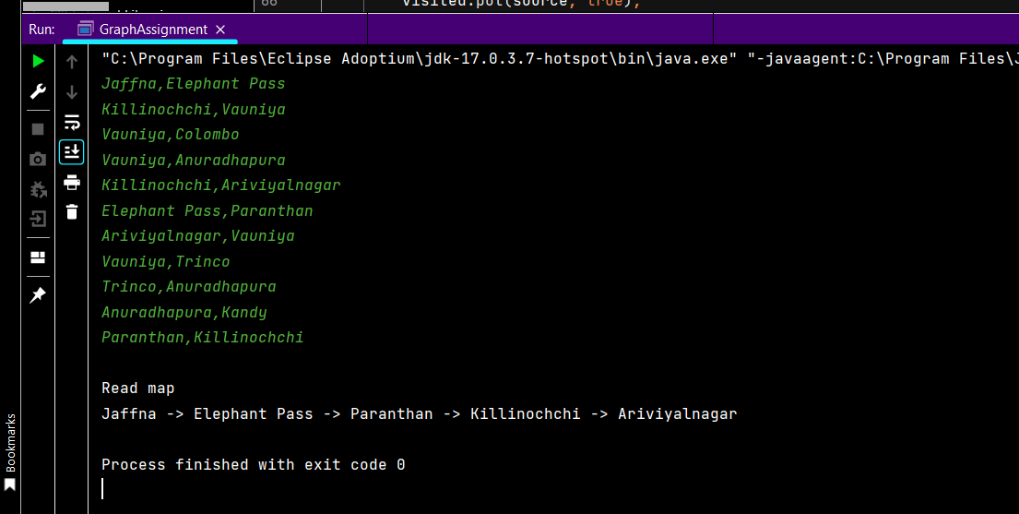

02.

